**Chapter 1**

**INTRODUCTION TO TECHNOLOGIES USED**

**(Tech-Stack)**

The technologies which we used in building the “Social Media” web application are as follows:

1. HTML
2. CSS
3. React JS
4. Node JS
5. Express JS
6. Mongo DB
   1. **HTML**

HTML stands for Hypertext Markup Language and it is a widely used programming language used to develop web pages. It defines how the web page looks and how to display content with the help of elements.

HTML stands for HyperText Markup Language. It is used to design web pages using a markup language. HTML is the combination of Hypertext and Markup language. Hypertext defines the link between web pages. A markup language is used to define the text document within the tag which defines the structure of web pages. This language is used to annotate (make notes for the computer) text so that a machine can understand it and manipulate text accordingly. Most markup languages (e.g. HTML) are human-readable. The language uses tags to define what manipulation has to be done on the text.

HTML is a markup language used by the browser to manipulate text, images, and other content, in order to display it in the required format. HTML was created by Tim Berners-Lee in 1991. The first-ever version of HTML was HTML 1.0, but the first standard version was HTML 2.0, published in 1995.

Elements and Tags: HTML uses predefined tags and elements which tell the browser how to properly display the content. Remember to include closing tags. If omitted, the browser applies the effect of the opening tag until the end of the page.

HTML page structure: The basic structure of an HTML page is laid out below. It contains the essential building-block elements (i.e. doctype declaration, HTML, head, title, and body elements) upon which all web pages are created.

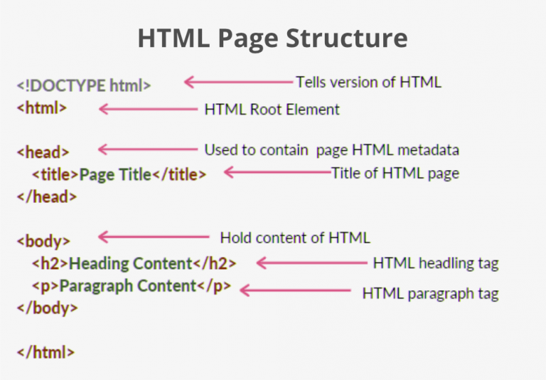

<!DOCTYPE html>: This is the document type declaration (not technically a tag). It declares a document as being an HTML document. The doctype declaration is not case-sensitive.

<html>: This is called the HTML root element. All other elements are contained within it.

<head>: The head tag contains the “behind the scenes” elements for a webpage. Elements within the head aren’t visible on the front-end of a webpage. HTML elements used inside the <head> element include:

<style>-This html tag allows us to insert styling into our webpages and make them appealing to look at with the help of CSS.

<title>-The title is what is displayed on the top of your browser when you visit a website and contains title of the webpage that you are viewing.

<base>-It specifies the base URL for all relative URL’s in a document.

<noscript>– Defines a section of HTML that is inserted when the scripting has been turned off in the users browser.

<script>-This tag is used to add functionality in the website with the help of JavaScript.

<meta>-This tag encloses the meta data of the website that must be loaded every time the website is visited. For eg:- the metadata charset allows you to use the standard UTF-8 encoding in your website. This in turn allows the users to view your webpage in the language of their choice. It is a self closing tag.

<link>– The ‘link’ tag is used to tie together HTML, CSS and JavaScript. It is self closing.

<body>: The body tag is used to enclose all the visible content of a webpage. In other words, the body content is what the browser will show on the front-end.

An HTML document can be created using any text editor. Save the text file using .html or .htm. Once saved as an HTML document, the file can be opened as a webpage in the browser.

It is used to make the skeleton of website. In HTML we use different tags to build the basic structure of the website. It provides variety of tags to fulfill different scenario designs.

We save the html file with .html file extension.

* 1. **CSS**

CSS stands for cascading style sheet. It is used to style the web pages. CSS allows you to put styles to customize your web pages. The best part about making use of this styling feature is that the CSS is independent of the HTML way of creating web pages.

Cascading Style Sheets, fondly referred to as CSS, is a simply designed language intended to simplify the process of making web pages presentable. CSS allows you to apply styles to web pages. More importantly, CSS enables you to do this independent of the HTML that makes up each web page. It describes how a webpage should look: it prescribes colors, fonts, spacing, and much more. In short, you can make your website look however you want. CSS lets developers and designers define how it behaves, including how elements are positioned in the browser.

While html uses tags, css uses rulesets. CSS is easy to learn and understand, but it provides powerful control over the presentation of an HTML document.

Difference between HTML and CSS is that HTML is used to give the basic structure to web page and CSS is used to give the pro level style to web page.

It is used to control the layout of more than one web page all at once. All the external stylesheets are stored in the form of CSS files.

CSS is used to control the style of a web document in a simple and easy way.

Applications of CSS:

CSS saves time

Page loads faster

Easy maintenance

Superior styles to HTML

Multiple device compatibility

Global web standards

CSS is a MUST for students and working professionals to become a great Software Engineer specially when they are working in Web Development Domain.

* 1. **React JS**

ReactJS is an open-source JavaScript library created by Facebook to make user interfaces for both web and mobile systems.

React is best for applications that change their data quickly and dynamically.

It can show the parts of the UI that are changing without re-rendering the whole page. Primarily React JS is used to make User Interfaces that loads faster than other basic HTML and CSS pages.

The basic working of React JS is that it doesn’t load the whole page from scratch it loads only that pages that is needed to be loaded and other parts of web page remains same. In this way React saves much more data specially in extensively used applications. And also, it saves the processing of the server. It saves much more bandwidth that is really a good thing.

ReactJS is a declarative, efficient, and flexible JavaScript library for building reusable UI components. It is an open-source, component-based front end library responsible only for the view layer of the application. It was created by Jordan Walke, who was a software engineer at Facebook. It was initially developed and maintained by Facebook and was later used in its products like WhatsApp & Instagram. Facebook developed ReactJS in 2011 in its newsfeed section, but it was released to the public in the month of May 2013.

Today, most of the websites are built using MVC (model view controller) architecture. In MVC architecture, React is the 'V' which stands for view, whereas the architecture is provided by the Redux or Flux.

A ReactJS application is made up of multiple components, each component responsible for outputting a small, reusable piece of HTML code. The components are the heart of all React applications. These Components can be nested with other components to allow complex applications to be built of simple building blocks. ReactJS uses virtual DOM based mechanism to fill data in HTML DOM. The virtual DOM works fast as it only changes individual DOM elements instead of reloading complete DOM every time.

* 1. **Node JS**

Node JS is a fast JavaScript runtime environment that we use to build server-side applications, but it does not know how to perform serving files, handling requests, and handling HTTP methods, so this is where express js comes in.

Node JS is an javascript run time environment uses V8 engine provided by google. It is used at server side to serve as sever to not only to the web pages but also to mobile and much more. It can be used as pure servers like other servers.

Node js uses NPM that is known as node package manager. By using npm we can install and uninstall external packages. It makes node Js a big thing to use at server side.

Node.js shines in real-time web applications employing push technology over WebSocket. After over 20 years of stateless-web based on the stateless request-response paradigm, we finally have web applications with real-time, two-way connections, where both the client and server can initiate communication, allowing them to exchange data more freely. This is in stark contrast to the typical web response paradigm, where the client always initiates communication.

Node.js is a platform that fills a particular need. It is not a silver bullet, or a platform that will dominate the web development world.

**Where to Use Node.js ?**

**Chat**

Chat is a typical real-time, multi-user application—from IRC (back in the day)—to modern implementations in Node.js with WebSocket.

**Data streaming**

In more traditional web platforms, HTTP requests and responses are treated like isolated events—although they’re actually streams. We can use this observation to build some cool Node.js features.

**Static web page**

We can use NodeJS to serve static web pages. This is very fast to serve static content.

* 1. **Express JS**

We have used express JS library that provides easy way to build a server.

Express is a node js web application framework that provides broad features for building web and mobile applications. It is used to build a single page, multipage, and hybrid web application.

It’s a layer built on the top of the Node js that helps manage servers and routes.

Advantages of express JS:

1. Middleware: express js provides middleware those have access to request response cycle. They can interfere request response cycle.
2. Routing: Routing provides different endpoints to client request.
3. Templating: express js supports different template engines that provides an facility to build a little bit dynamic pages.
4. Debugging: In express js, it is easy to debug the code as we have to check only the specific endpoint to which we are sending request.
5. Fast: No doubt, express js serves files much more fast specifically static pages.

Express.js tutorial provides basic and advanced concepts of Express.js. Our Express.js tutorial is designed for beginners and professionals both.

Express.js is a web framework for Node.js. It is a fast, robust and asynchronous in nature.

Our Express.js tutorial includes all topics of Express.js such as Express.js installation on windows and linux, request object, response object, get method, post method, cookie management, scaffolding, file upload, template etc.

Main features of express js:

* It can be used to design single-page, multi-page and hybrid web applications.
* It allows to setup middlewares to respond to HTTP Requests.
* It defines a routing table which is used to perform different actions based on HTTP method and URL.
* It allows to dynamically render HTML Pages based on passing arguments to templates.
  1. **Mongo DB**

MongoDB is open-source database that is based on NOSQL. NoSQL databases are quite useful for working with large sets of distributed data. MongoDB is a tool that can manage document-oriented information, store or retrieve information.

Working of Mongo DB

MongoDB makes use of records which are made up of documents that contain a data structure composed of field and value pairs. Documents are the basic unit of data in MongoDB. The documents are similar to JavaScript Object Notation, but use a variant called Binary JSON (BSON). The benefit of using BSON is that it accommodates more data types. The fields in these documents are similar to the columns in a relational database. Values contained can be a variety of data types, including other documents, arrays and arrays of documents, according to the MongoDB user manual. Documents will also incorporate a primary key as a unique identifier.

MongoDB scales data in horizontal scale. It makes searching data very easy and fast.

Set of data is known as collections in mongo DB. Collections are like tables in SQL. The MongoDB architecture is made up of collections and documents.

**Features of mongodb:**

* Support ad hoc queries
* Indexing
* Replication
* Load balancing
* Duplication of data
* It also supports:
  + JSON data model with dynamic schemas
  + Auto-sharding for horizontal scalability
  + Built in replication for high availability

**Chapter 2**

**SDLC - (Software Development Life Cycle)**

**2.1 Introduction:**

The Software Development Life Cycle (SDLC) is a structured process that enables the production of high-quality, low-cost software, in the shortest possible production time. The goal of the SDLC is to produce superior software that meets and exceeds all customer expectations and demands. The SDLC defines and outlines a detailed plan with stages, or phases, that each encompass their own process and deliverables. Adherence to the SDLC enhances development speed and minimizes project risks and costs associated with alternative methods of production.

There are many ways to implement the software development like:

* Waterfall model
* Spiral model
* Advanced waterfall model
* V-shaped
* Iterative model
* Agile
* Big bang model

But to build very complex model( software) we need an SDLC model that is risk oriented. That is very responsive to the need of users.

So we choose spiral model as it is risk oriented and it has many features that makes it suitable for the swagZinn.

**2.2 SPIRAL MODEL**

The spiral model is a systems development lifecycle (SDLC) method used for risk management that combines the iterative development process model with elements of the Waterfall model. The spiral model is used by software engineers and is favored for large, expensive and complicated projects.

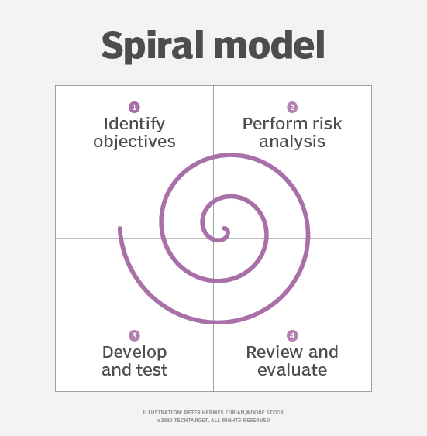

**Fig. 2.1 Spiral Modal Diagram**

When viewed as a diagram, the spiral model looks like a coil with many loops. The number of loops varies based on each project and is often designated by the project manager. Each loop of the spiral is a phase in the software development process.

Uses of the spiral model

The spiral model is best used in large, expensive and complicated projects.

Other uses include:

* projects in which frequent releases are necessary.
* Frequent changes are required
* High risk
* Project with complex requirements
* Unknown cost parameter
* Long term projects

Spiral model phases

When looking at a diagram of a spiral model, the radius of the spiral represents the cost of the project and the angular degree represents the progress made in the current phase. Each phase begins with a goal for the design and ends when the developer or client reviews the progress.

Every phase can be broken into four quadrants:

* Identifying and understanding requirements
* Performing risk analysis
* Building the prototype
* Evaluation of the software's performance.

1. Identifying and understanding requirements:

We have studied the basic need of particular module in this step like working on signing up in the swagZinn, which kind of information we will need to get authorize the user and password encryption methods.

1. Performing Risk Analysis:

. We have studied in the risk associated with every module of software like password hacking, unauthorized access to swagZinn. We encrypted everything in swagZinn.

1. Building the prototype:

We designed the every module in this step and coded in javascript language. We analyzed the test cases of the prototype like in signup how about signup with duplicate email id .

1. Evaluation of software performance:

In this step, we finally evaluate the performance of each step. We analyze performance on various factors like loading time of page. Response time of functions of module. Errors in module.

Other benefits of the spiral model include:

* Software changes can be easily achieved.
* Risk handling is easy
* Customers are satisfied by the product as at each phase software is deployed

Spiral model was very suitable for us to implement such kind of service that is changing time to time and trends are coming so much in market like comment, likes and shares. It gonna help us when we will be improving SwagZinn.

Limitations of spiral model:

* In this way, software building is costly.
* Much more dependency on risk analysis.
* On the limitations I can say that spiral was very hard to implement and was very time consuming for us. We are analyzing thing much more and even very simple things were taking so much time to get completed.

When we are making this project report still we are planning to implement some features in SwagZinn, it shows how much time consuming is this spiral model. But it allows to deploy the minimal software build that is very usefull. We can deploy an very small working part of project to show to users(client).

**Chapter 3**

**Feasibility Study**

**3.1 Introduction:**

Feasibility study is the second phase of the project building after selecting the project.

We can say, feasibility study assesses operational, financial and technical aspects of proposal. It should be done at right time basically before the system design process. Basically it access that is it possible to make the product with available resources.

In this process we consider almost all factors like financial, technical, resources, marketing, demand of product etc.

We can say that feasibility study is the way by which we check, is it good to build the product for financial gains. It helps use to determine the risk and returns of a plan of action.

Feasibility study helps the project management team to check the feasibility of the software whether the software is really worth it to build.

We study the business case in the feasibility study. We check the risk of the project building. If the risk is low and benefit is high, then project team choose to build the project otherwise they reject the project.

Sometimes project feasibility study also includes the requirement analysis as project feasibility is directly linked to the requirements of the project.

**3.2 Types of feasibility study:**

Following are the different types of feasibility study:

* Economic
* Technical
* Behavioral
* Operational

1. **Economic**

In economic feasibility study, we study how much money will needed to build the product. And how much this product will help organization to grow financially. In economic study we analyze the financial aspects of project. It gives basic idea of financial support distribution between project team.

**We observe these things in economic feasibility study:**

* Money needed to learn react , express js , deployment
* Economic risk associated with project like it is worth it to build.
* Financial support by project to organization like is it will be valid project to college to accept to being and minor project for course.
* Benefits of project to us like concern of success of project.

1. **Technical**

Technical feasibility study analyzes the technical aspect connected with project.

Team looks for the hardware and software required for completing the project. Like technical and hardware requirements of software project. Like our project needs core i3 as hardware and React, node JS as software part.

**We observe these things in technical feasibility study:**

* Hardware requirements of project like we need i3 processor to implement swagZinn.
* Software requirements of project like we need vs code nodejs and react to implement swagZinn.
* Other resources associated with project like I worked on photoshop to optimize photos to put on swagZinn like the logo of swagZinn.
* Training requirements of staff to build to project like I was required to learn react in-depth express js and serving files to front-end by express.
* Maintenance cost associated with project after deploy like we have deployed the project on firebase so we analyzed the cost associated with firebase.
* Need of employment of staff to complete the project like what can affect us to complete the project like optimization of college syllabus wih the available time.

1. **Behavioral**

An estimate should be made of how strong a reaction the user staff is likely to have towards the development of a computerized system It is common knowledge that computer installation have something to do with Turnover, Transfers and changes in employee Job Status.

1. **Operational**

An operational feasibility study evaluates whether or not your organization is able to complete this project. This includes staffing requirements, organizational structure, and any applicable legal requirements. At the end of the operational feasibility study, your team will have a sense of whether or not you have the resources, skills, and competencies to complete this work.

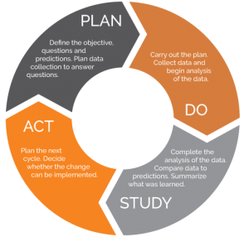

**Fig.3.1 Feasibility Study Phases**

Plan: we plan each module in this step like signup login logout and post adding, post saving.

Do: We analyze and collect data to implement the modules.

Study: We study the prosed change with the current solution. Like updating the signup details.

Act: if the change was good then we implement the change and publish it on service.

**Chapter 4**

**System Analysis**

The main purpose of conducting system analysis is to study the various processes and to find out its requirements.

These may include ways of capturing or processing data, producing information, controlling a business activity or supporting management.

The determination of requirements entrails studying the existing details about it to find out what these requirements are.

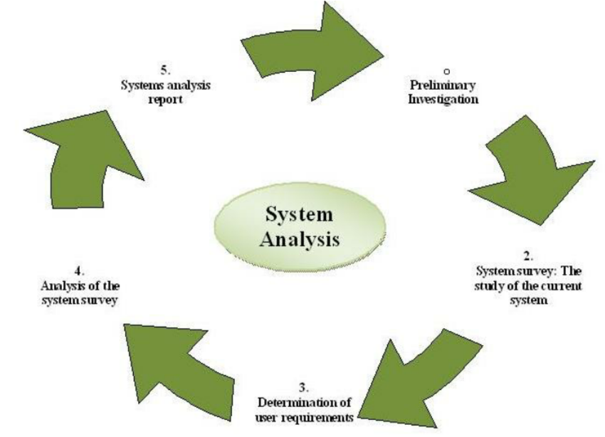

**Fig. 4.1 Steps in System Analysis**

System analysis has been conducted with the following objectives in mind:

* We analysed various needs associated with social media apps.
* We evaluated the feasibility of swagZinn features.
* We performed economic and technical feasibility study of swagZinn.
* Allocate functions to hardware, software, people, database and other system elements.
* We find out the services need to be implemented to implement swagZinn.
* Establish cost and schedule constraints as we set the deadline to complete this project within three months.

Importance of System Analysis:

* It improved the productivity of us.
* Reduced errors when developing modules.
* Identifies potential issues in code
* Helps businesses improve our system

System Analysis of SwagZinn:

* Building a system of posting photos to express themselves.
* Building a system that is secure to use.
* Building a system that doesn’t collect data of user.
* Building a system that doesn’t show ads o users.

SwagZinn software functions:

* A user can register himself and login.
* A user can login and start posting things.
* A user can follow others like his friends.
* A user can chat with peoples.

**Chapter 5**

**Project Monitoring System - Planning**

**5.1 Introduction:**

Project planning is a discipline addressing how to complete a project in a certain timeframe, usually with defined stages and designated resources. It gives the basic idea of time to complete the tasks of project.

One view of project planning divides the activity into these steps:

* setting measurable objectives like signup login post sharing post saving following peoples.
* identifying deliverables like we initially implemented post sharing features.
* Scheduling each module implementation deadlines.
* planning tasks like post saving time.

Enterprises often have an information technology project planning guide that identifies the processes used. Tools used for the scheduling parts of a plan include Gantt charts and PERT charts.

Project planning is important at every phase of a project. It lays out the basics of a project, including the following:

* scope of swagZinn.
* Objectives of swagZinn.
* Goals of swagZinn.
* Schedule of swagZinn.

Planning enables project managers to turn an intangible idea into reality.

**5.2 Gantt Chart**

A Gantt chart is a commonly used graphical depiction of a project schedule. It's a type of bar chart showing the start and finish dates of a project's elements such as resources, planning, and dependencies.

The Gantt chart is the most widely used chart in project management. These charts are useful in planning a project and defining the sequence of tasks that require completion. In most instances, the chart is displayed as a horizontal bar chart.

Horizontal bars of different lengths represent the project timeline, which can include task sequences, duration, and the start and end dates for each task. The horizontal bar also shows how much of a task requires completion.

A Gantt chart helps in scheduling, managing, and monitoring specific tasks and resources in a project. The chart shows the project timeline, which includes scheduled and completed work over a period of time. The Gantt chart aids project managers in communicating project status and completion rate of specific tasks within a project, and also helps ensure the project remains on track. By convention, it is a standard tool that makes communication unified among the engineering and project management community.

|  |  |  |  |  |  |  |  |  |  |  |  |  |  |  |  |  |  |  |  |
| --- | --- | --- | --- | --- | --- | --- | --- | --- | --- | --- | --- | --- | --- | --- | --- | --- | --- | --- | --- |
|  | **September** | | | | | **October** | | | | | | **November** | | | | **December** | | | |
| **Requirements**  **Gathering** |  | | |  | |  | | | | | |  | | | |  | | | |
| **Analysis** |  | | |  | |  | | |  | | |  | | | |  | | | |
| **Design** |  | | | | |  |  | | | | |  | | | |  | | | |
| **Coding** |  | | | | |  | | | |  | |  | | |  |  | | | |
| **Testing** |  | | | | |  | | | | | |  | | |  |  |  | | |
| **Implementation** |  | | | | |  | | | | | |  | | | |  |  |  | |
|  | W1 | W2 | W3 | | W4 | W5 | W6 | W7 | | | W8 | W9 | W10 | W11 | W12 | W13 | W14 | W15 | W16 |

**Table 5.1 Gantt chart of SwagZinn**

**Chapter 6**

**System Requirements & Specifications**

**6.1 Introduction:**

When we are about to build some software project, then we have some requirements. We write down them in a document. That document is known as SRS i.e. software requirement and specification document.

Basically, SRS describe the requirements associated with project. And specification of the software functionality.

In general words, SRS is the picture of our entire project. SRS have in-depth description of the project.

SRS describe the requirements and describe how to overcome from the requirements. It describes all resources associated with project and how to overcome out of them.

Functions of Software Requirement and specification

* SRS defines the internal calculations
* It describes the internal details
* It works as an agreement between client and company.

**6.2 Hardware Requirements are as follows**

Processor : Intel i3 or Later

RAM : 4 GB or More

Hard disk : 50GB or more

Monitor : Any Compatible Monitor

Keyboard & Mouse : Any QWERTY Keyboard and compatible Mouse

**6.3 Software Requirements are as follows**

Front-End : HTML, CSS, JavaScript, Bootstrap, React JS

Backend : Express JS, Node JS

Database : Mongo DB

IDE : VS Code

Web-Browser : Mozilla Firefox, Google Chrome, Microsoft Edge

Window : Linux, Windows 7 & later supporting Node JS.

**Chapter 7**

**System Design**

**7.1 Introduction**

System design is the core of software process. When we are about to build a system, its system design is the important part. This improves the thinkability of programmer. It lands in the efficient program. In system design we check the software development quality. We administrate every process and module of the software for perfection. It helps team to build an efficient system. Without it we cannot build an efficient and well designed system. Without system designing, system will not be testable, debug. We will not be able to test the quality of the system.

As per technical point of view, System design is divided into four types: design user interface, architectural design, procedural design, and data structural design. The main thing is that we have to produce a model of an entity that we can later will build.

On the next page, the diagram shows the System description for SwagZinn.

**Fig. 6.1 Entity Relationship diagram**

Has Account?

user

Login

signup

Manage

following

Save post

profile

post

**7.3 Entity Relationship Dictionary**

1. **User Entity**

A user can create account in swagZinn and can login and connect with world and his loved ones.

Attributes:

Name: name of the user

Password: password of the user

User id: user id of the user

1. **Login**

A user can login into his account by the login dashboard and can use swagZinn.

Attributes:

Email: email enterd while signing-up

Password: password filled when signing-up

1. **Sign-up**

A user can sign-up and can create new account in swagZinn. There is nothing like boundation in using swagZinn.

Attributes:

FullName: name of user

Email: email of user

Password: password of user

1. **Following**

A user can follow number of users worldwide. And can interact with their posts.

Attributes:

User id: array of followed accounts.

1. **Post**

A user can create post after login. And another users can interact with posts.

Attributes:

User id: creator user id

File: file of the post

Desc: description of post

Date : date of posting

Location: location of post

1. **Saved Post:**

A user can save post of other users and also of his itself. These posts can be viewed separately.

Attributes:

Post id: post id of post

User id: user id of user by which pos is saved

1. **Profile**

A user can view his profile also. Like he can view his profile picture and cover picture. A user can also logout by here.

Attributes:

Logout: logout by account.

Grid view: Grid view of posts

Card view: card view of posts

Saved post: saved posts by user.

**Chapter 8**

**Flow Chart**

A flowchart is a diagram that depicts a process, system or computer algorithm. They are widely used in multiple fields to document, study, plan, improve and communicate often complex processes in clear, easy-to-understand diagrams. Flowcharts, sometimes spelled as flow charts, use rectangles, ovals, diamonds and potentially numerous other shapes to define the type of step, along with connecting arrows to define flow and sequence. They can range from simple, hand-drawn charts to comprehensive computer-drawn diagrams depicting multiple steps and routes. If we consider all the various forms of flowcharts, they are one of the most common diagrams on the planet, used by both technical and non-technical people in numerous fields. Flowcharts are sometimes called by more specialized names such as Process Flowchart, Process Map, Functional Flowchart, Business Process Mapping, Business Process Modeling and Notation (BPMN), or Process Flow Diagram (PFD). They are related to other popular diagrams, such as Data Flow Diagrams (DFDs) and Unified Modeling Language (UML) Activity Diagrams.

**Social media** is a simple and easy to use social media platform where users can post their content. Every software that is needed to build this project is available freely on internet by officials. And hardware we own.

We have used flow chart:

* To develop understanding of how a process is to be done
* To study a fields needing improvements.
* To communicate to others how a process should be made.
* When better communication is needed between people involved with the same process
* To document a the process of swagZinn.
* We planned the overall swagZinn with the flowchart.

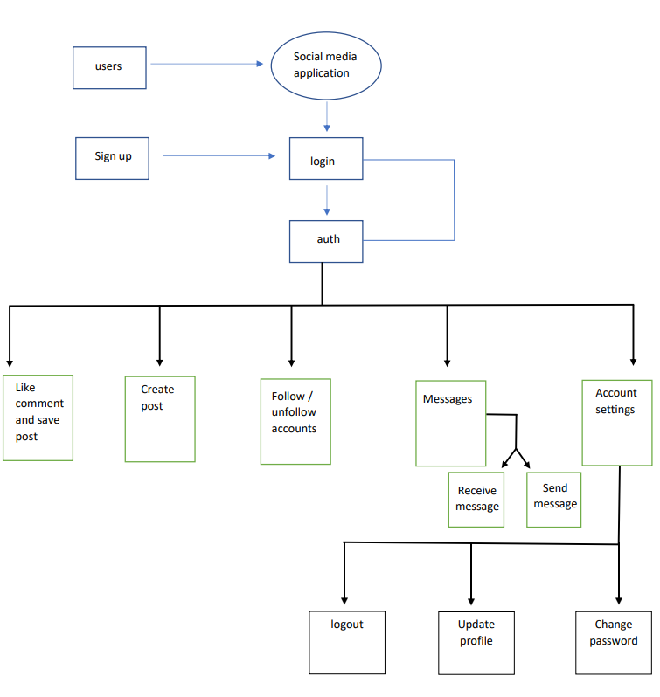

**Fig. 7.1 Flow Chart of SwagZinn**

**Chapter 9**

**Data Modelling Description**

**9.1 Introduction**

A data model is the conceptual representation of the data structures of that are required by a database. It defines primary data objects, composition, of each data object and attributes of the project, relationships between each object and other object and between objects and processes.

**9.2 List of Tables**

1. Users
2. Post
3. Comments
4. Likes
5. Saved
6. Following/Friends
7. TotalFollowing
8. **Users**

|  |  |
| --- | --- |
| **Name** | **Type** |
| Uid | Varchar(255) |
| Username | Varchar(255) |
| Email | Varchar(255) |
| password | Varchar(255) |

**Table 9.1 User Database Model**

1. **Post**

|  |  |
| --- | --- |
| **Name** | **Type** |
| PID | Varchar(255) |
| Uid | Varchar(255) |
| File | Boolean |
| Desc | Varchar(255) |
| Date-time | Datetime(255) |

**Table 9.2 User Post Model**

1. **Comments**

|  |  |
| --- | --- |
| **Name** | **Type** |
| Pid | Varchar(255) |
| Uid | Varchar(255) |
| Comment | Varchar |
| time | datetime |

**Table 9.3 Comment Model**

1. **Likes**

|  |  |
| --- | --- |
| **Name** | **Type** |
| Pid | Varchar(255) |
| Users | Varchar(255) |
| Total | Varchar(255) |

**Table 9.4 Likes Model**

1. **Saved**

|  |  |
| --- | --- |
| **Name** | **Type** |
| Sid | Text |
| Pid | Text |
| datetime | time |

**Table 9.5 Saved Model**

1. **Following/Friends**

|  |  |
| --- | --- |
| **Name** | **Type** |
| Uid | Varchar(255) |
| Following | Array of Uids |

**Table 9.6 Following Model**

1. **Total Following**

|  |  |
| --- | --- |
| **Name** | **Type** |
| Uid | Varchar(255) |
| TotalFollowing | Number |

**Table 9.7 TotalFollowing Model**

**Main Description of the module**

All the above mentioned data are stored in the backend and will be used by the designed algorithms.

**Chapter 10**

**Data Flow Diagram**

Data flow diagrams (DFD) are part of a structed model in the development of software. They are a graphical technique that depicts information flow and the transforms that are applied as data move from input to output. Basically, the function of DFDs is to show the user a graphical analysis of a software system. It is like a flowchart, except DFDs show the flow of data throughout the system.

**Data Flow Diagram Symbols**

* **:** Data Flow
* **:** Process
* **:** Entity
* **:** Data

User information

Social Media App.

e

**Users**

Posts, likes, comments, chats, follow requests

Response

System Maintenance

**Admin**

**Fig. 9.1 0th level – Data Flow Diagram**

user

Social media application

Authenticate user account

Social media application

User account database

Admin

Update system information

Validate and

verify account

User account information

Edit profile, posts and uploads

Data store

Manage database

Manage System

**Fig. 9.2 1st level – Data Flow Diagram**

Response

Request

Response

Request

Authentication

**Users**

Post

Request

Request

**Posts**

Response

Response

Users

Request

Request

Response

Saved Post

**Saved Post**

Response

Request

Response

Request

Response

Request

Response

Response

Request

Following

**Messages**

**Following**

Chat.

**Fig. 9.3 2nd level – Data Flow Diagram**

**Chapter 11**

**Project Design**

**11.1 Database Design:**

1. Database design and collections

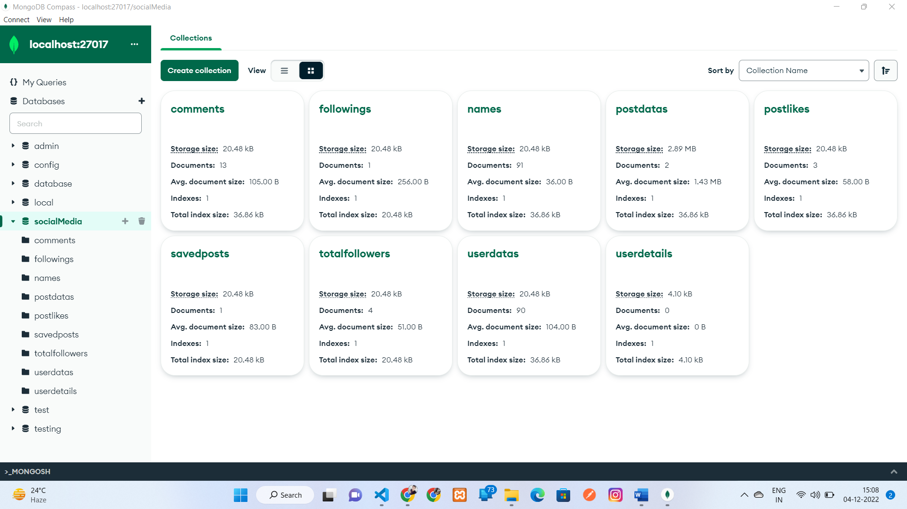

1. Comment stored in database

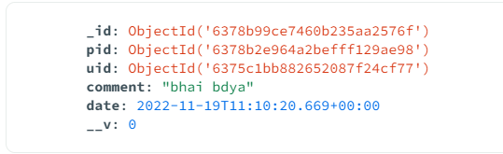

1. Following list in database

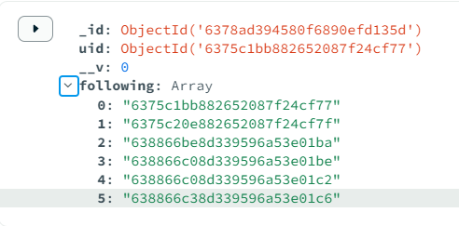

1. Names stored in database

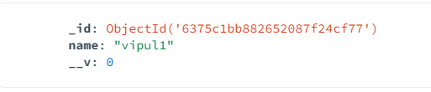

1. Post stored in database

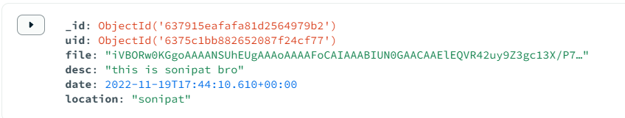

1. Post likes stored in database

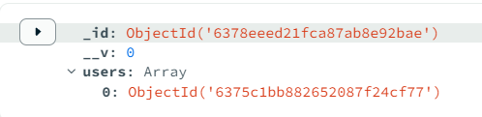

1. Saved post in database

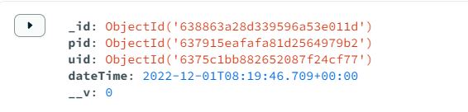

1. Total followers stored in database

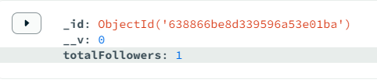

1. User data stored in database

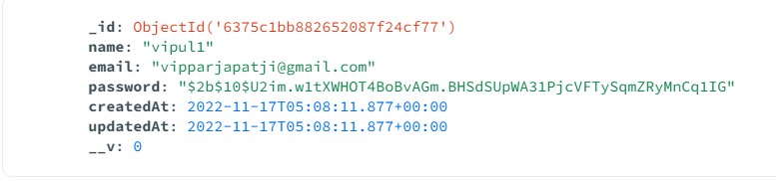

**11.2 Screen Designs:**

1. Landing page of SwagZinn

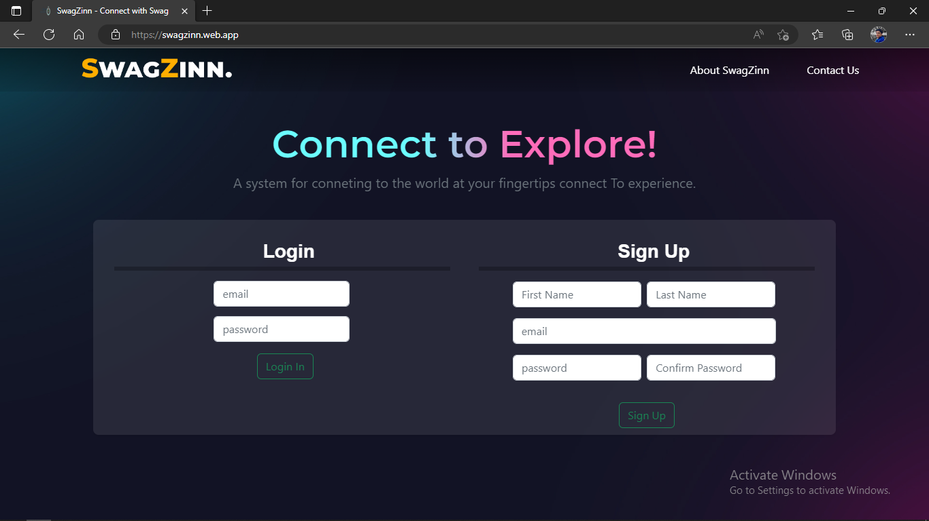

Responsive:

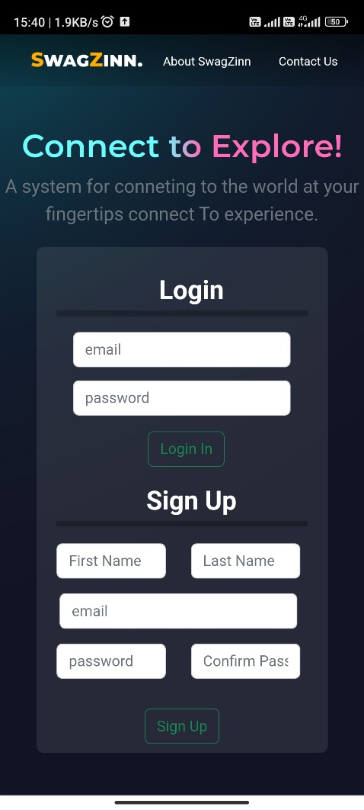

1. Home page of SwagZinn

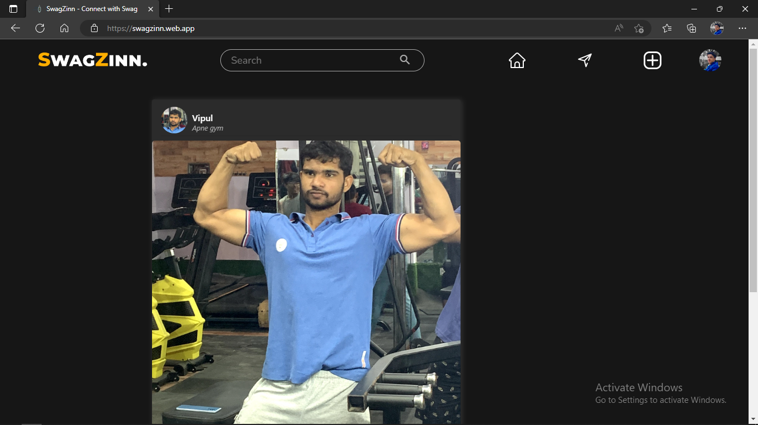

Responsive:

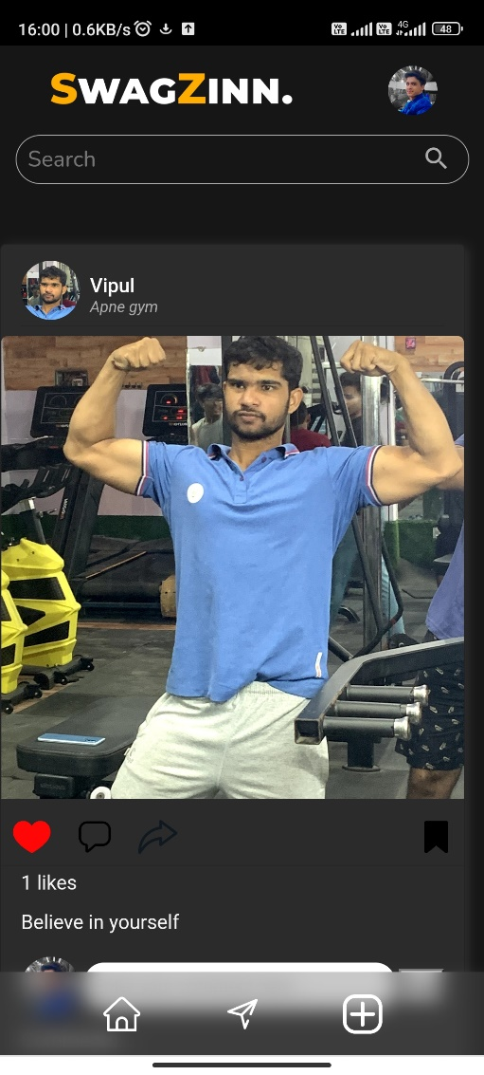

1. Adding post in SwagZinn

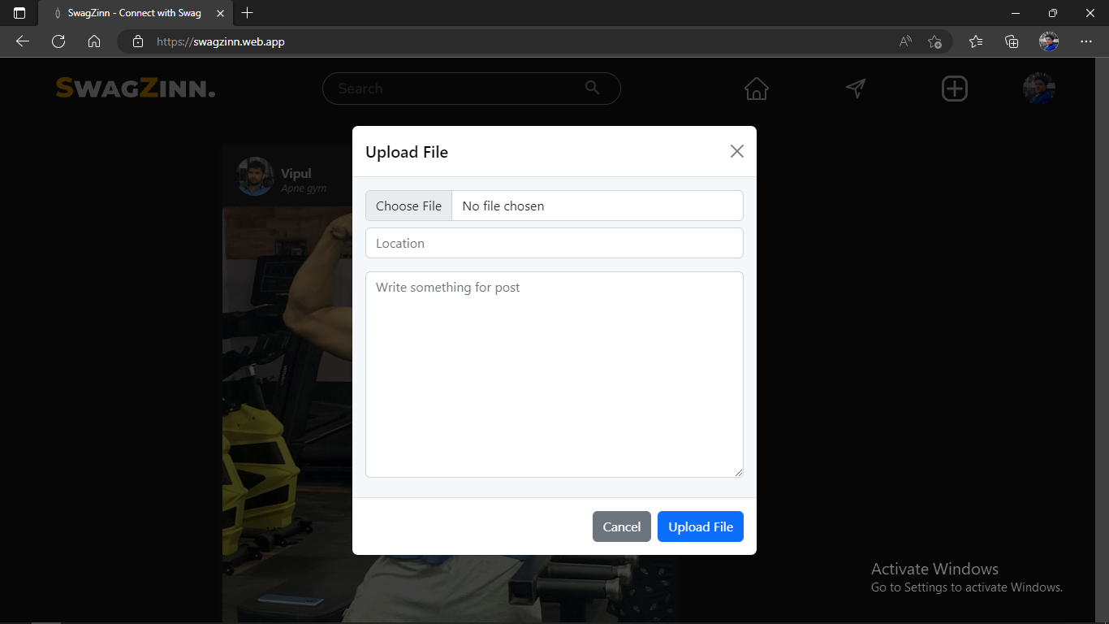

Responsive:

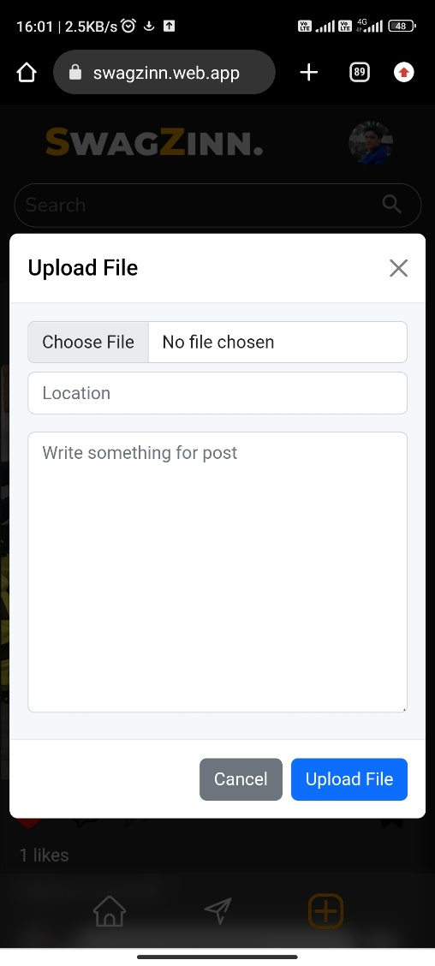

1. My profile in SwagZinn

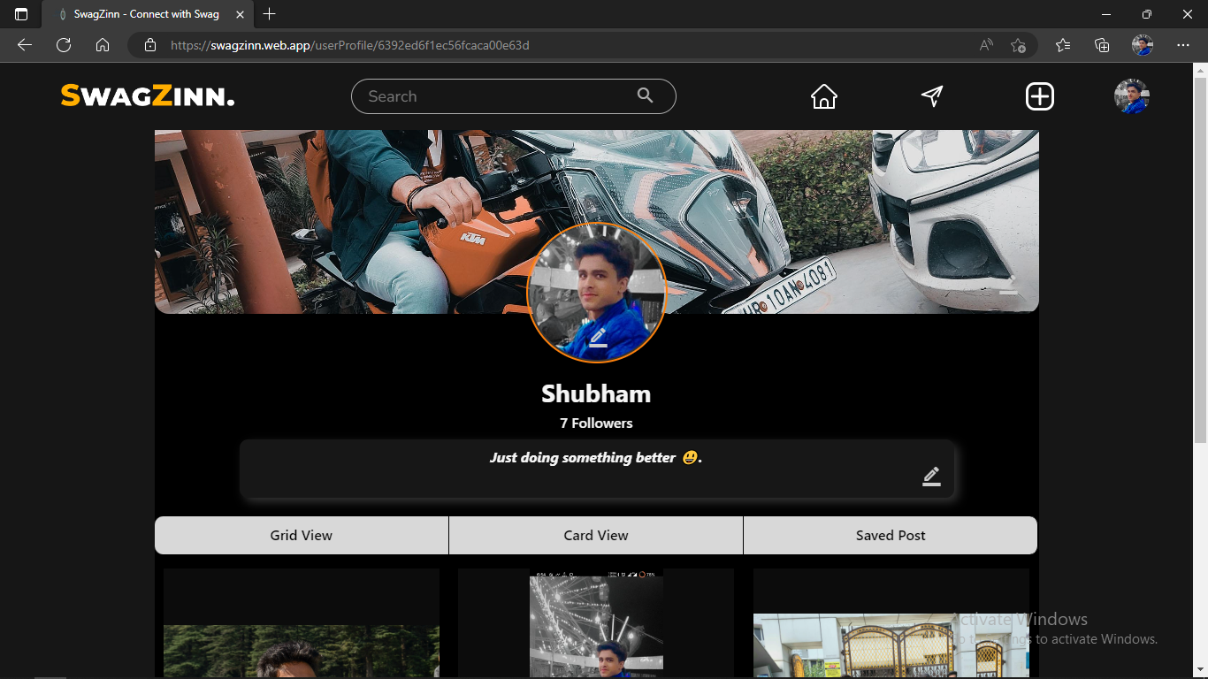

Responsive

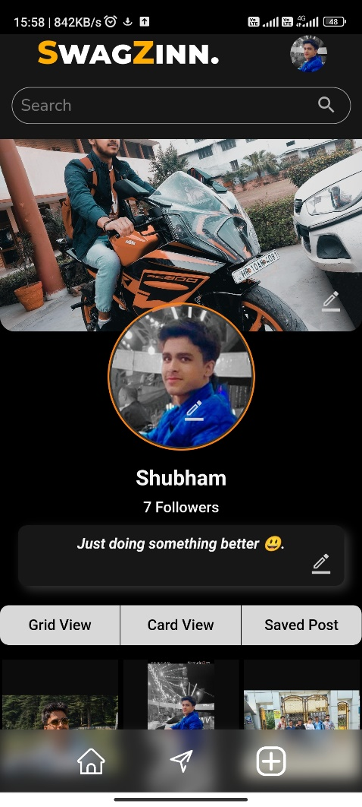

1. My Profile Grid View

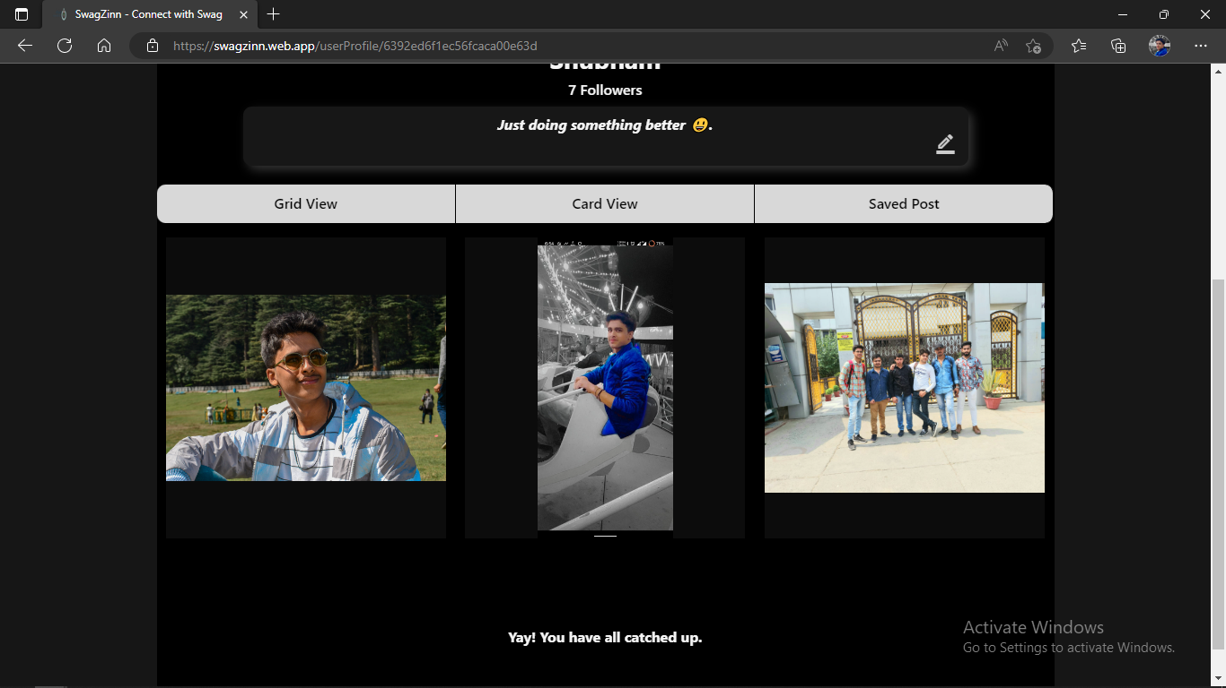

Responsive:

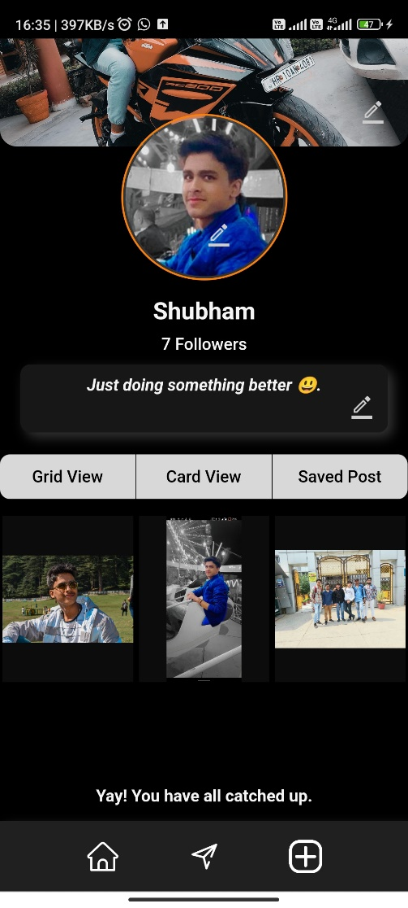

1. My Profile Card View

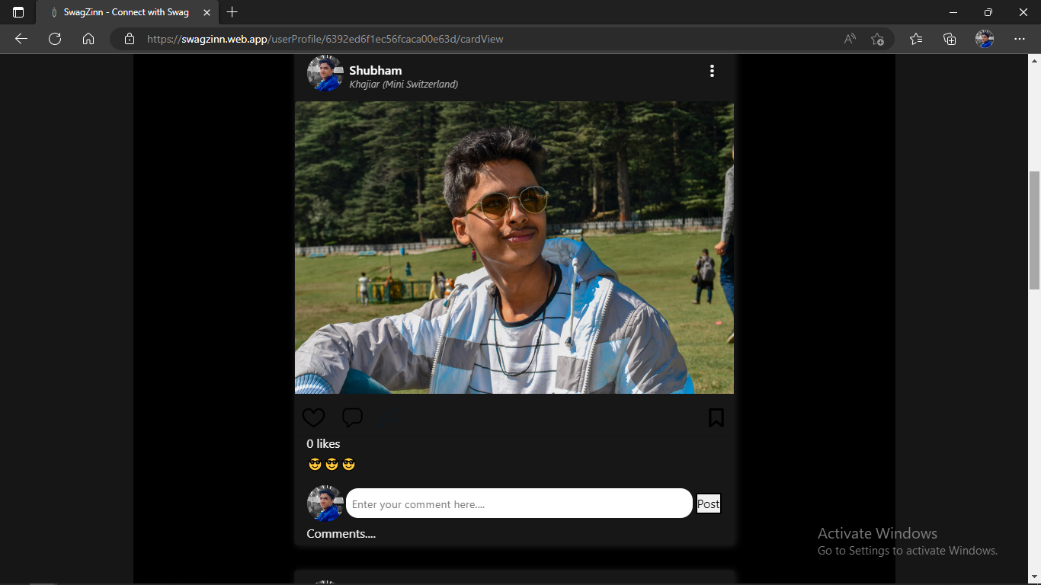

Responsive:

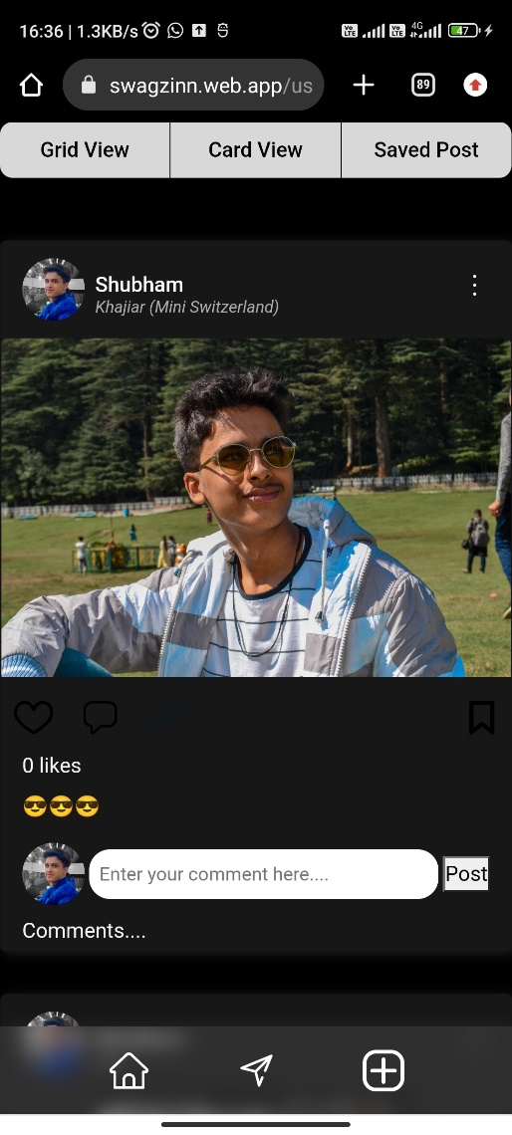

1. My Profile Saved Post

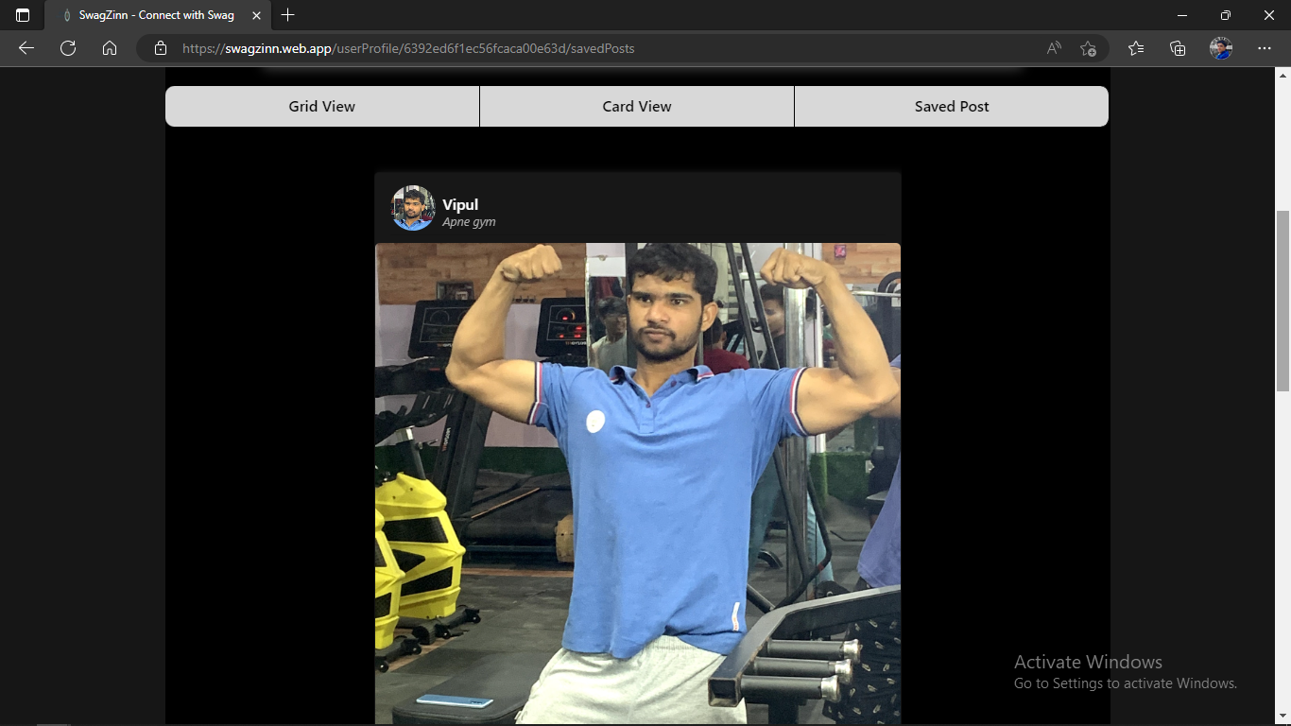

1. My Post Delete



1. Searching accounts

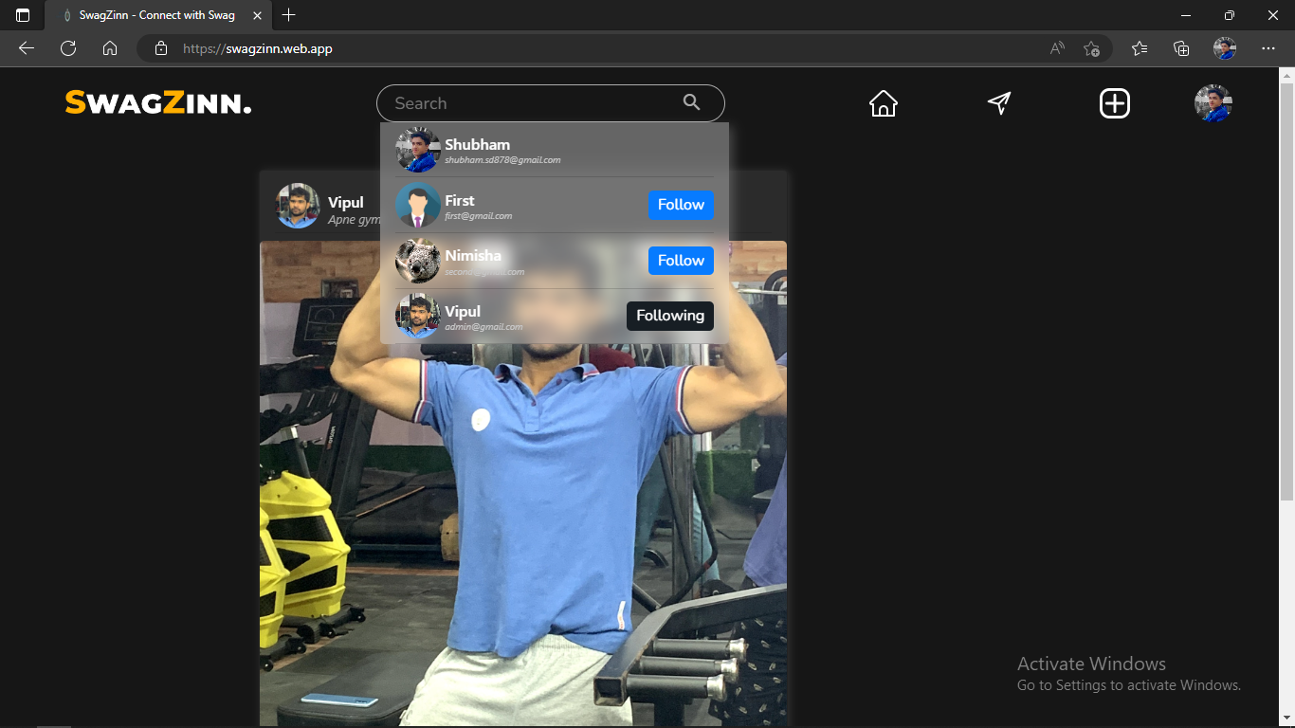

Responsive:

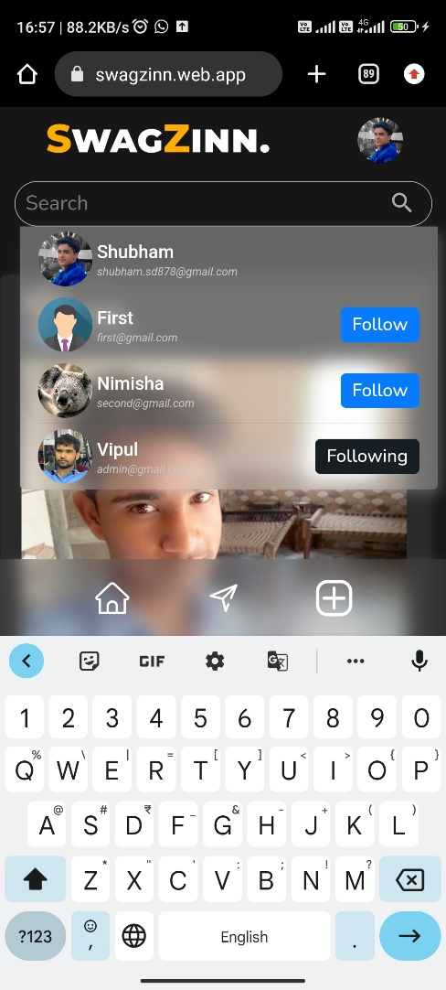

1. Adding comment

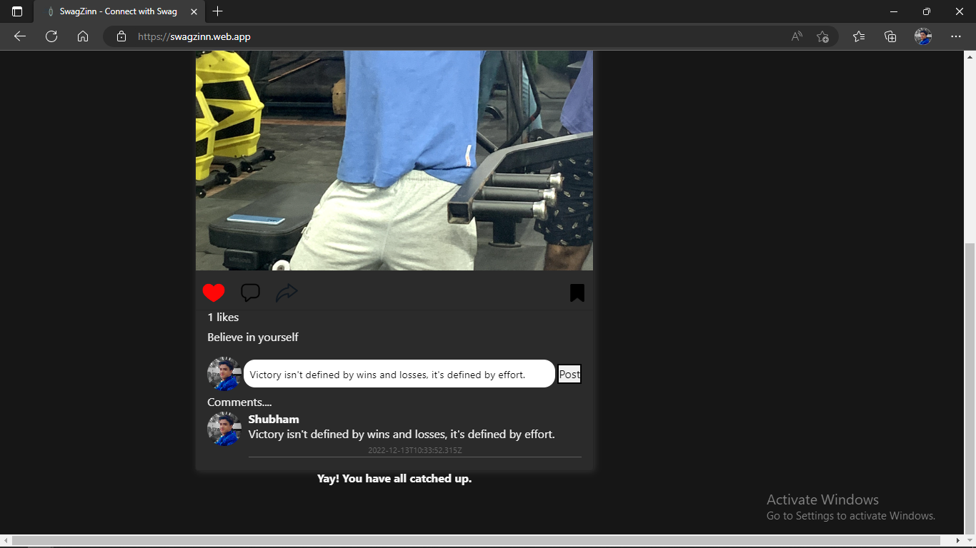

Responsive:

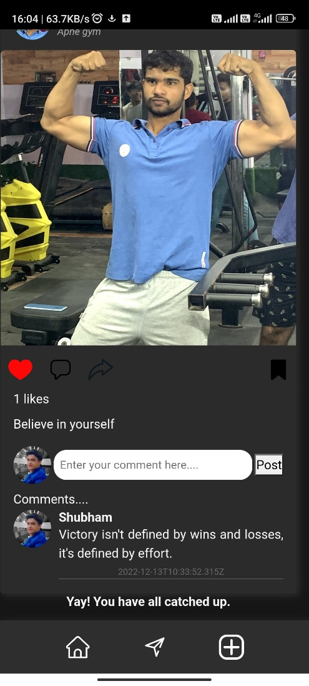

1. Other’s profile in SwagZinn:

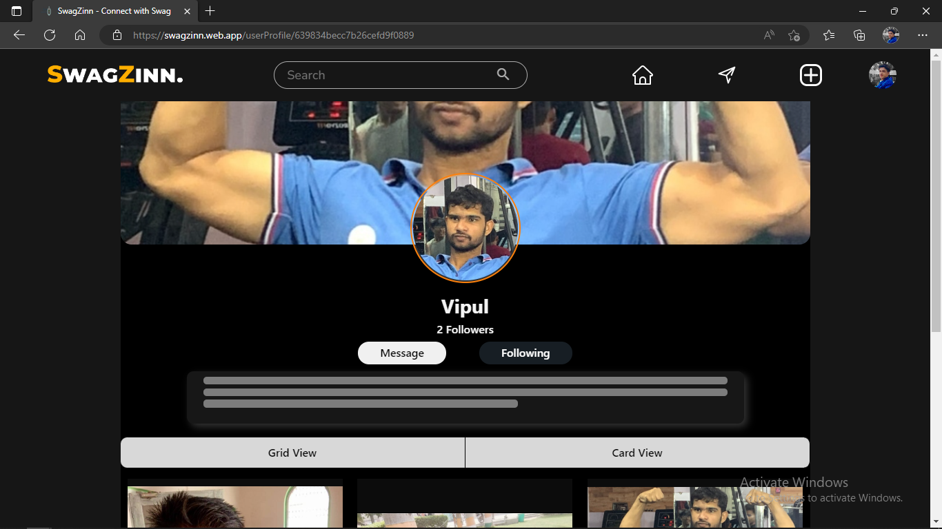

Responsive:

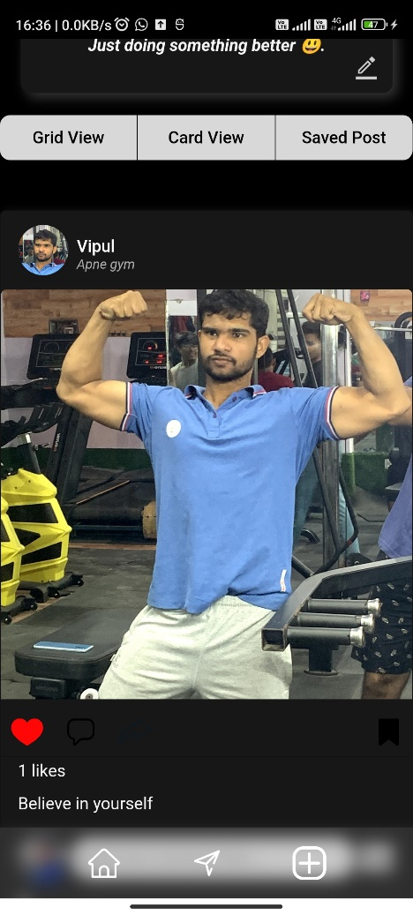

12. Others Profile Grid View

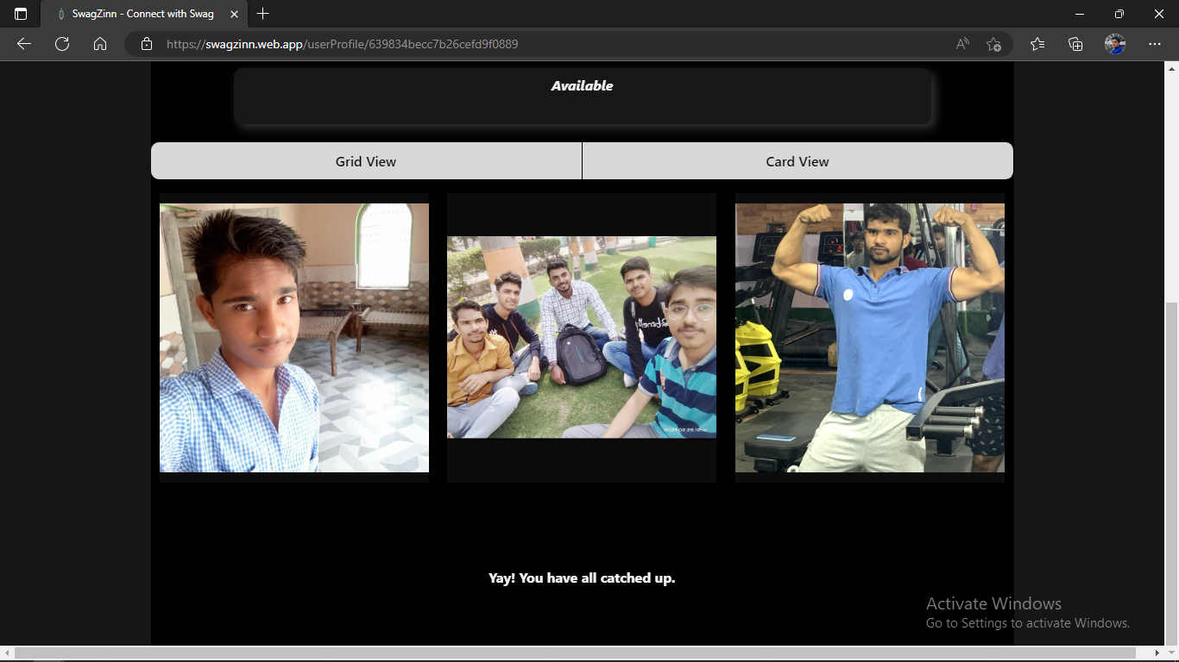

Responsive:

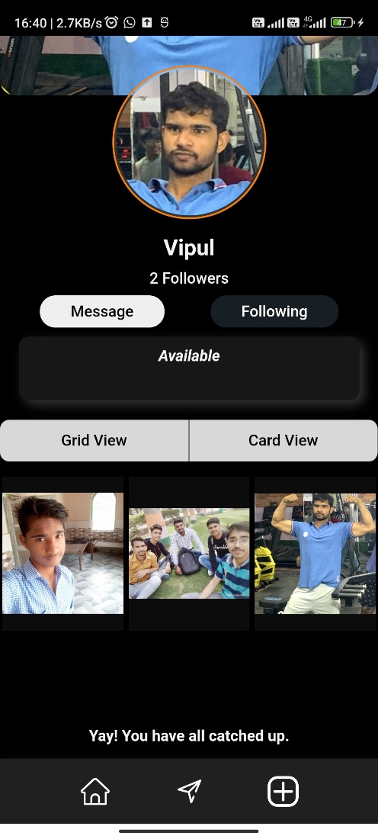

13. Others Profile Card View

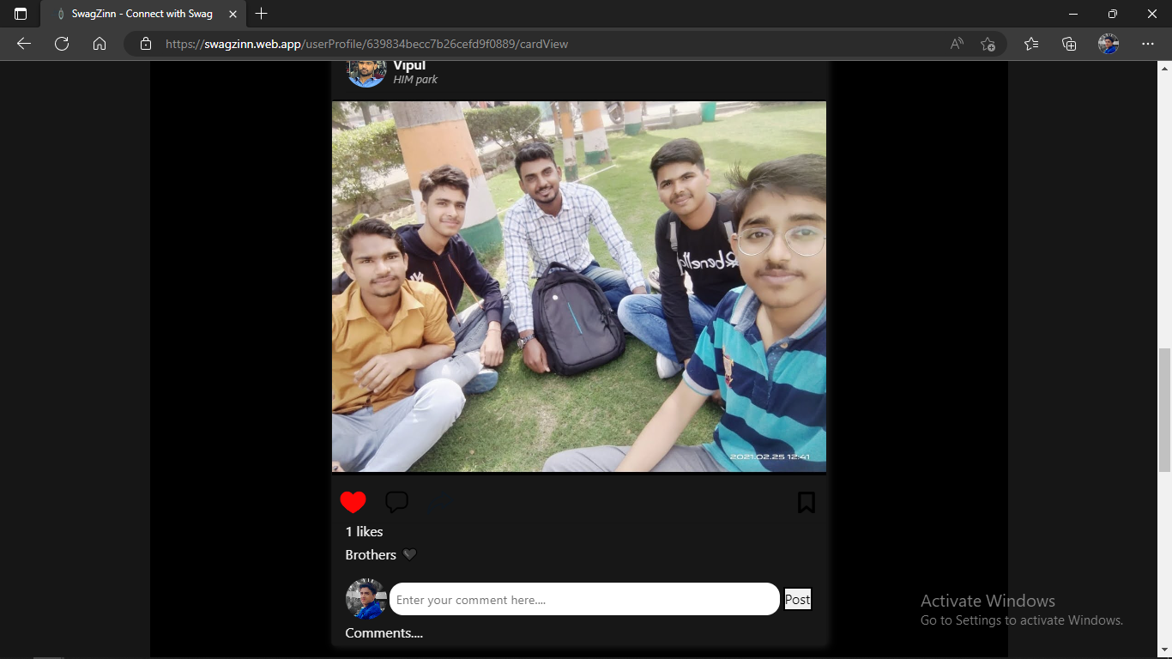

Responsive:

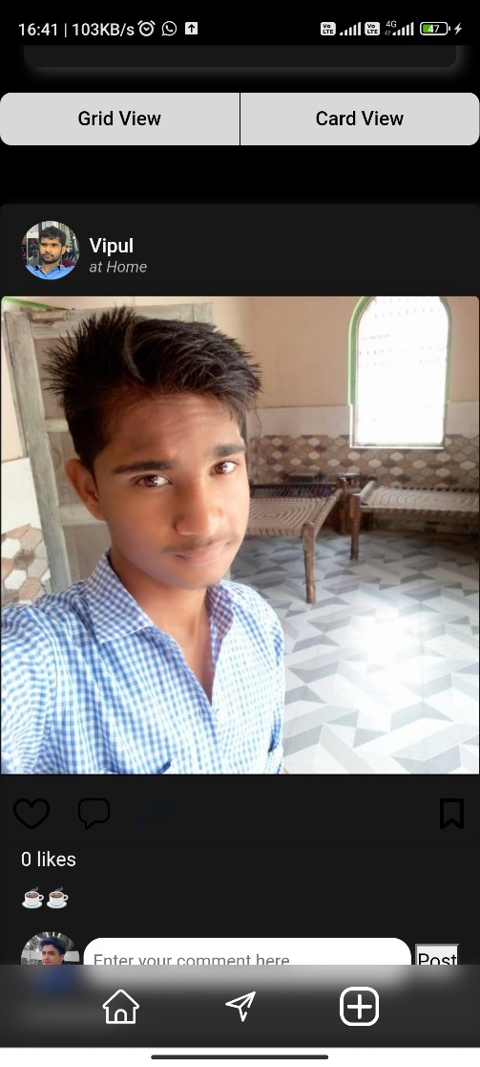

**Chapter 12**

**Testing**

Testing is the phase in which we test our service whether it works as expected or not. We can test our project in this phase. It is important step because in this step we can check our project for errors. We generate test cases those help us to test our project.

Testing helps us improve performance of project.  *Performed after integration testing.* Usually, testing is done by different team independent of development team.

Those implementations are of two types like:

1. User testing
2. System testing

Acceptance testing

Unit testing

System testing

Integration testing

**Fig. 12.1 Types of Testing**

**Fig. 12.2 Software Testing Strategies**

1. **Signup and login testing**

|  |  |  |  |
| --- | --- | --- | --- |
| **TEST** | **CASE** | **EXPECTED** | **RESULT** |
| Signup | Insufficient details | Error fill the details | PASS |
| Signup | Enter email without @ | @ is required | PASS |
| Signup | All details correctly filled | Popup for Successful Registration | PASS |
| Sign In | Enter correct details | login | PASS |
| Sign In | Enter incorrect details | Show invalid details | PASS |
| Sign In | After login redirect to home page | Redirection to home page | PASS |

**Table 12.1 Signup and Login Testing**

**SignUp**

1. Insufficient details

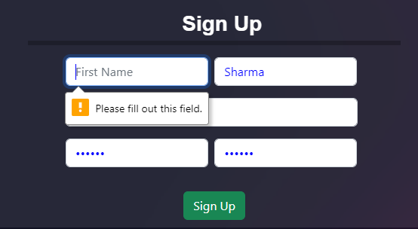

If all the details are not filled up then sign up will not be completed. Prompt will be showing one by one to fill up the details.

1. Enter email without @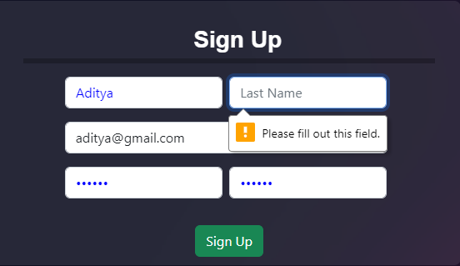

If user tries to signup without proper email format then it will not be able to signup.

1. Details properly filled

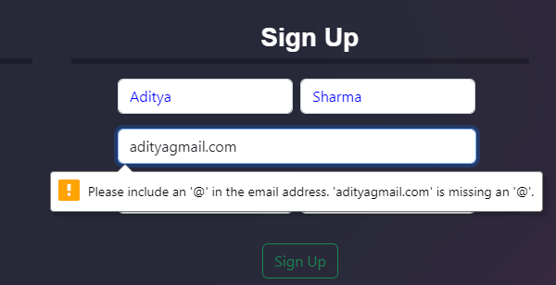

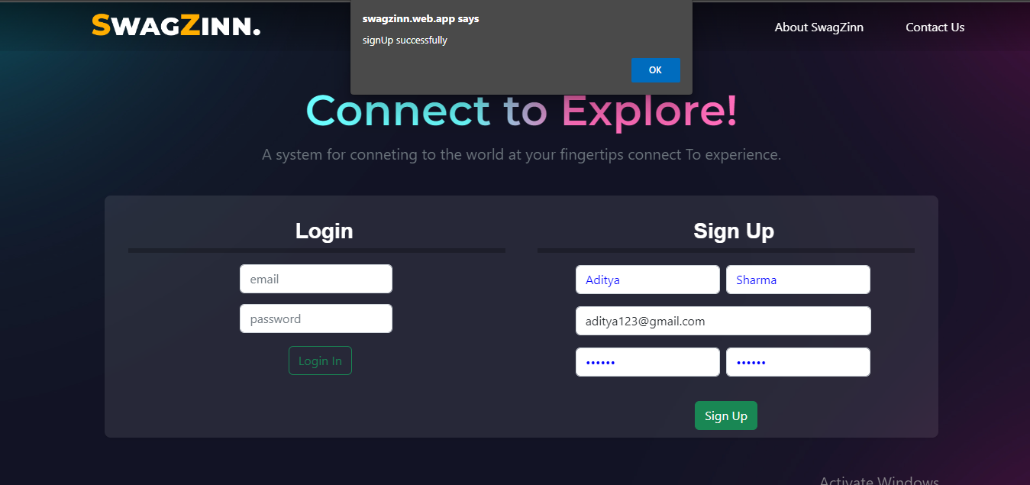

If all the details are properly filled then a user will be signed up and a alert will be shown saying that signup successful then user will be able to login to swagZinn.

**Login**

1. Enter incorrect details

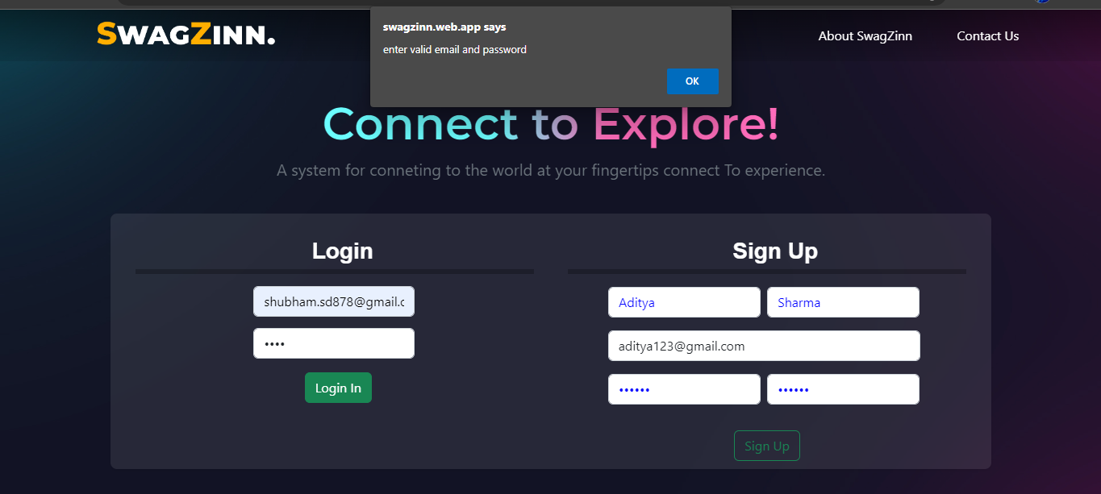

If email and password are incorrect then a alert will be shown to saying either username or password is incorrect.

1. After login redirect to home page

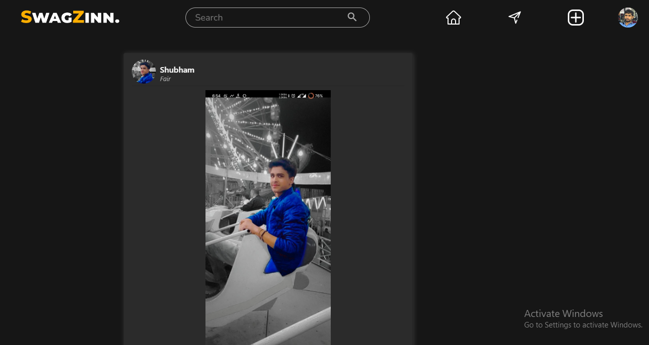

If a user filles email and password correct then user will be redirected to home page of swagZinn showing posts of following users.

1. **User search bar**

|  |  |  |  |
| --- | --- | --- | --- |
| **TEST** | **CASE** | **EXPECTED** | **RESULT** |
| Enter valid username | Exact Username search | Account found | PASS |
| Enter matching username | Matching username entered | Probably account found | PASS |
| Bigger username than actual | More characters searched | Account not found | PASS |

**Table 12.2 User Search Bar Testing**

1. Exact Username search

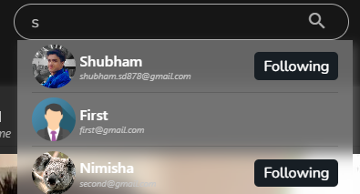

2. Matching username entered

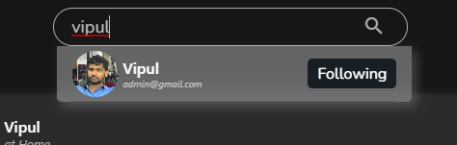

3. More characters searched

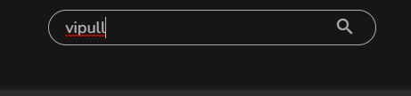

1. **Post upload**

|  |  |  |  |
| --- | --- | --- | --- |
| **TEST** | **CASE** | **EXPECTED** | **RESULT** |
| Filled all fields | All Details filled | File upload | PASS |
| Upload without file | Upload without file selected | File upload failed | PASS |
| Upload without desc | Upload without description | File upload | PASS |
| Upload without location | Unfilled location column | File upload | PASS |
| Upload empty form | All fields are empty | File upload failed | PASS |

**Table 12.3 Post Upload Testing**

1. Filled all fields

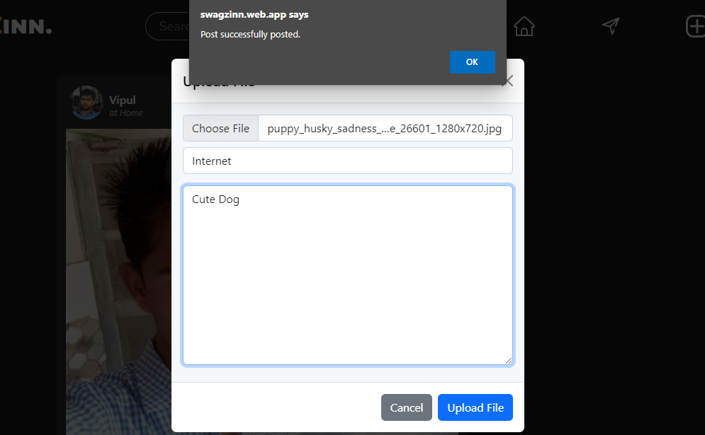

If all the fields are filled propery. Then post gets added. And a prompt saying post successfully added is shown to user to tell the user post is added. By default post is public and if user post something it will be instantly visible to all other users.

1. Upload without file

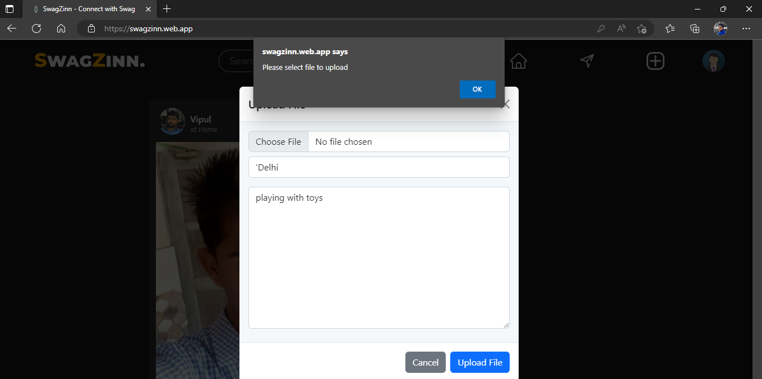

If user tries to upload post without file then operation will be rejected by swagZinn.

1. Upload without desc

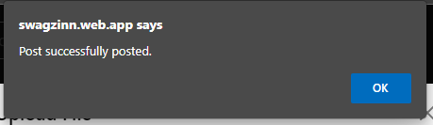

If post is uploaded without then post will be uploaded on server and will be visible to others.

1. Upload without location

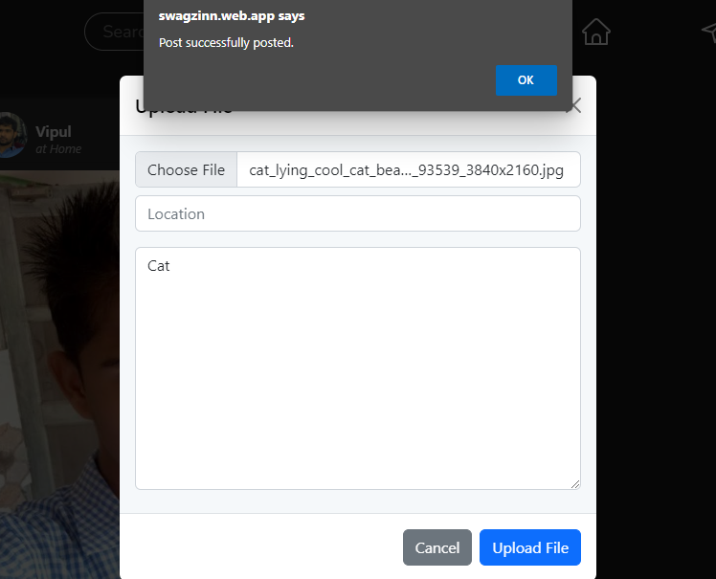

If user tries to upload the post without filling location, then post will be upload because location field is not mandatory field.

1. Upload empty form

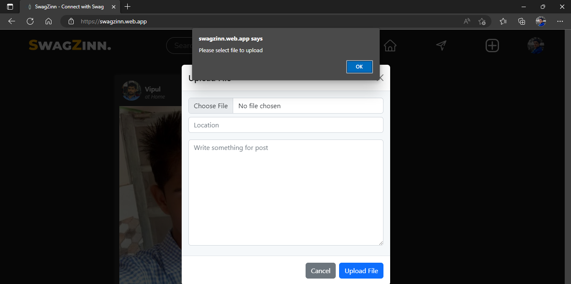

If user tries to upload empty post, then it will be rejected by swagZinn.

1. **Comment box**

|  |  |  |  |
| --- | --- | --- | --- |
| **TEST** | **CASE** | **EXPECTED** | **RESULT** |
| Comment typed | Comment field filled | Comment added | PASS |
| Comment not typed | Comment field empty | Comment not added | PASS |

**Table 12.4 Comment Box Testing**.

1. Comment Typed:



If the comment is typed on comment section and user click on post button then comment will be added to the post.

1. Comment not typed:

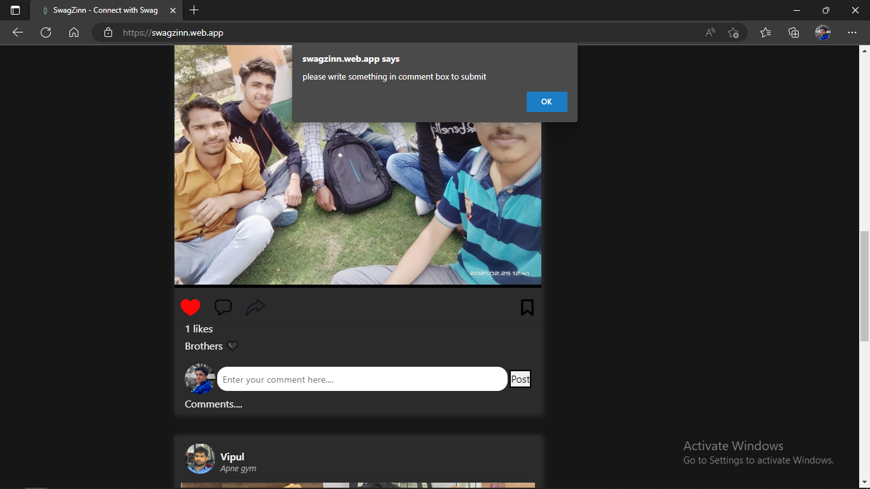

If comment is not typed then swagZinn will say to write something in comment section of post.

1. **Follow/Unfollow**

|  |  |  |  |
| --- | --- | --- | --- |
| **TEST** | **CASE** | **EXPECTED** | **RESULT** |
| Follow from search | Follow | File Follow | PASS |
| Unfollow from Search | Unfollow | Unfollow | PASS |
| Follow From Profile | Follow | Follow | PASS |
| Unfollow From Profile | Unfollow | Unfollow | PASS |

**Table 12.5 Follow/Unfollow Testing**

1. Follow from Search

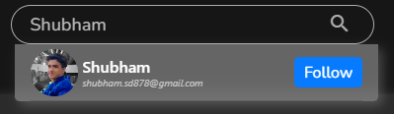

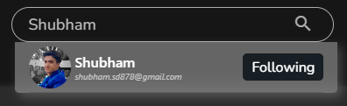

If user search for accounts in search section and click on follow button then user will be followed.

1. Unfollow from Search

If user search account and click on unfollow button then user will be unfollowed.

1. Follow from Profile

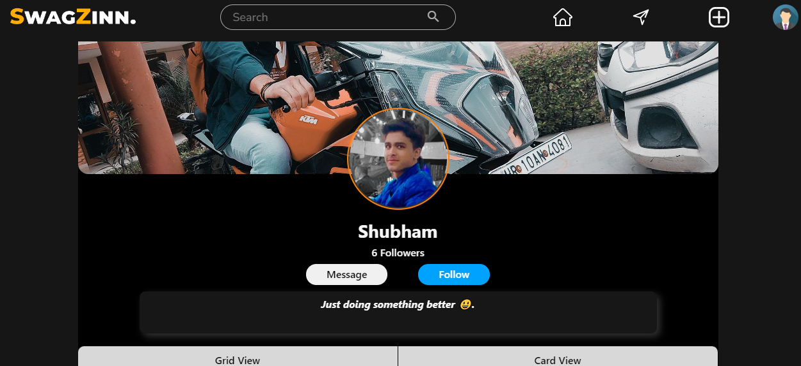

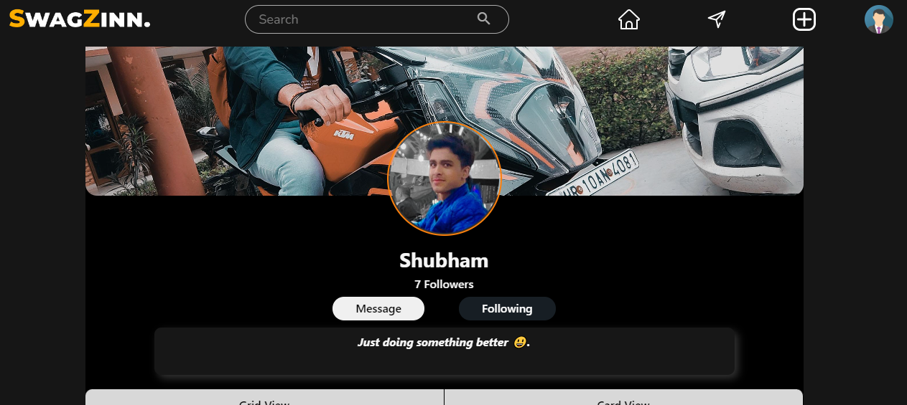

If you go to the profile of user of swagZinn then you can also follow from there directly.

1. Unfollow from Profile



A user can directly unfollow another user from the account(home) page of other user.

**6. Posts**

|  |  |  |  |
| --- | --- | --- | --- |
| **TEST** | **CASE** | **EXPECTED** | **RESULT** |
| Fetching Posts of Following users in sort of date-time | Fetch Posts | Fetch posts of following users in sort of date-time | PASS |
| Like Post | Like | Like | PASS |
| Comment Post | Comment | Comment | PASS |
| Save Post | Save Post | Save Post | PASS |

**Table 12.6 Post Testing**

1. Fetching posts by date time 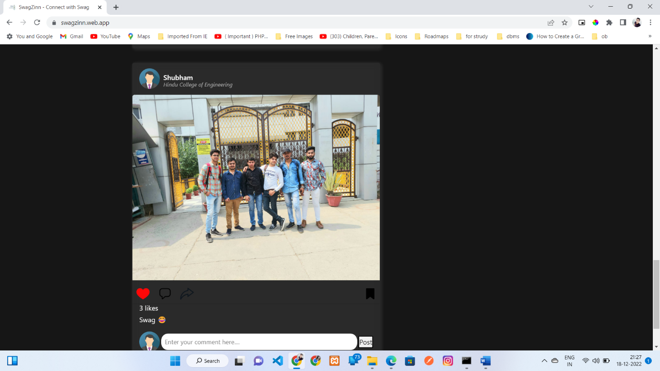
2. Like post

Unliked post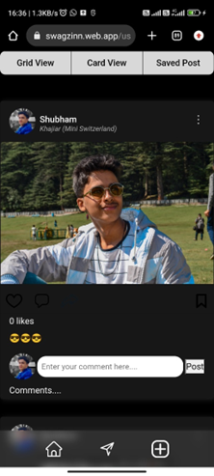

Liked post



When you like the photo it became the liked photo with red heart symbol and if you click again it became unliked photo. By default photo is unliked.

1. Comment on post

A swagzinn user can comment on post to whom he is following. And comments can be seen in comment section. When you click on “comments”, Previous comments will show up.

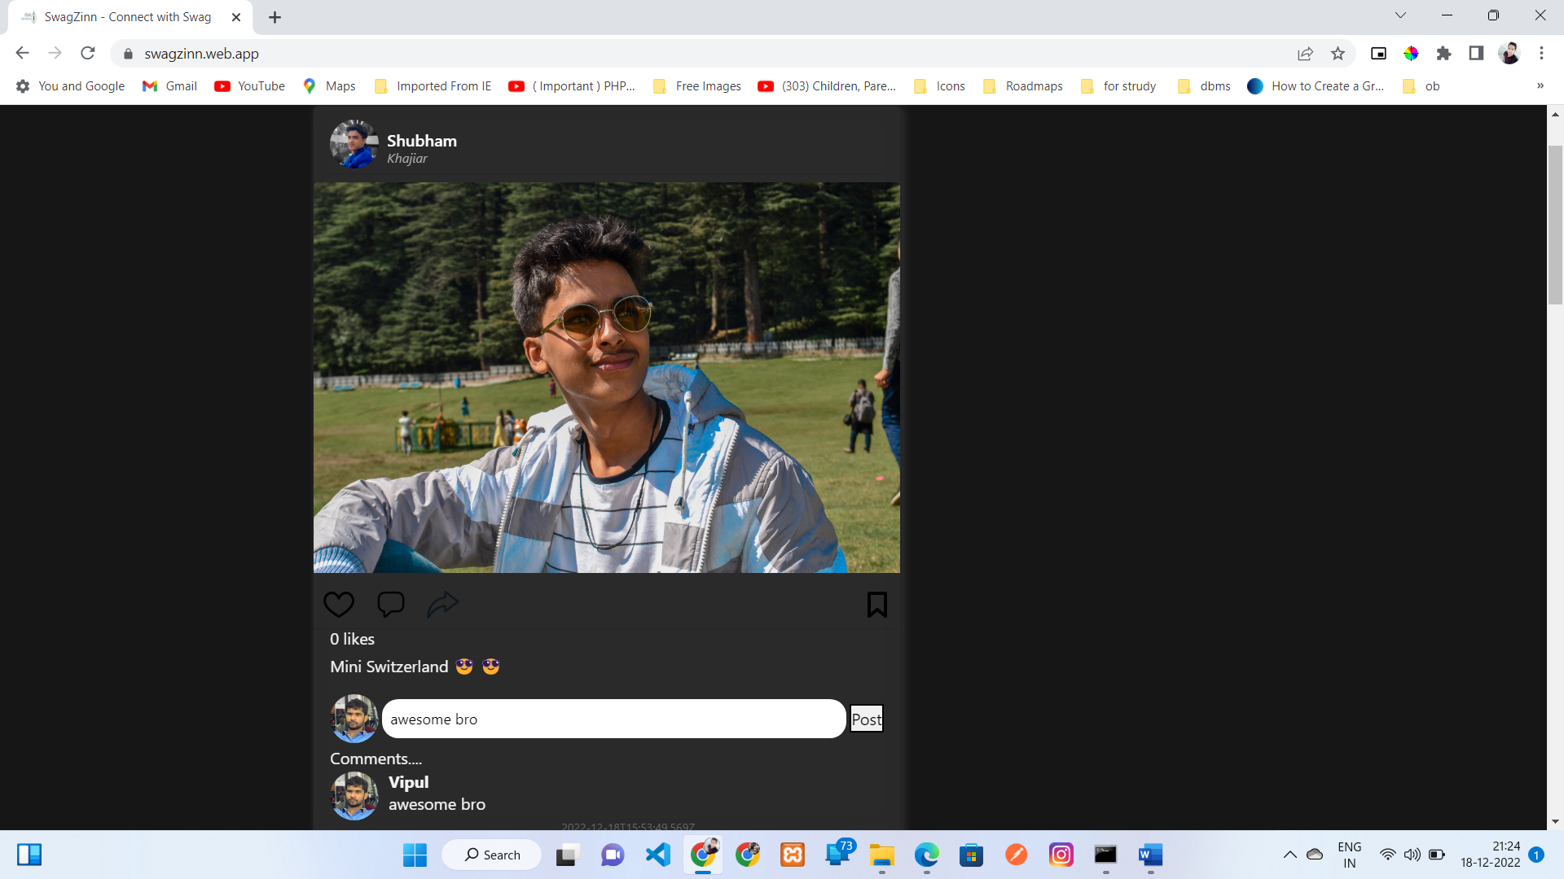

1. Save post

A user can save the post once you click on save post icon. Once a user click on save post icon, user can view the post on the saved post section of the my profile.

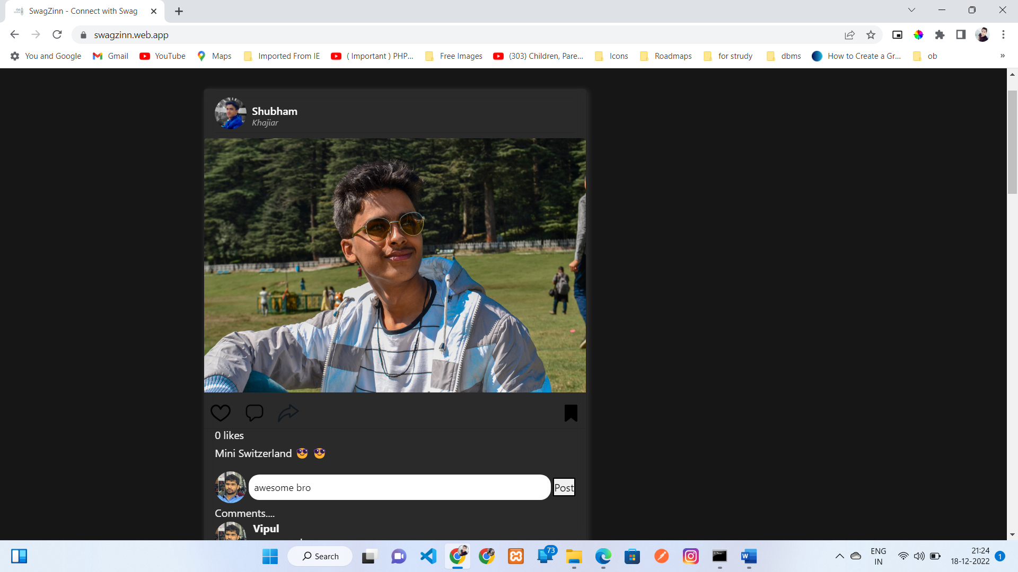

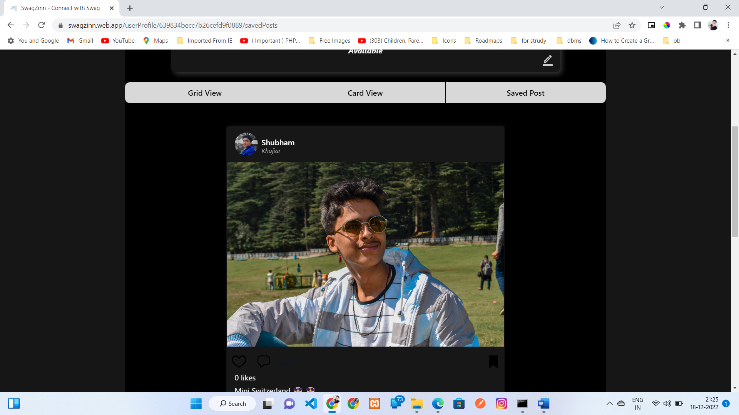

**Chapter 13**

**System Implementation**

**Implementation tools:**

In the development of swagZinn, we have used following technologies:

* React JS:

To load the pages with the less interactions with server. And to minimize the bandwidth of network and to minimize the compute of server.

* Node JS:

To implement the server that can work very fast and based on specific routes based requests.

* Express JS:

To code the server that is fast and reliable to use . And most important easy to code and maintain.

* Mongo DB:

To store the data associated with swagZinn. It is the very powerful database used by bid companies.

**Implementation methods:**

It can be done in three ways:

* Parallel
* Phased
* pilot
* Direct

1. **Parallel**

When the new system is used at the same time as the old system the two systems are said to be running in parallel.

Advantages of Parallel:

* Users can compare the output of the old system with the output of the new system, to ensure correctness
* There is little risk of data loss because the known-good system is running

Disadvantages:

* Users must take more time to enter data into two different systems
* Data could be different in two different systems if there is intensive data entry.

1. **Phased**

When small parts of the new system gradually replace small parts of the old system, the implementation method is said to be phased.

We have used this technique when updating the swagZinn at the last of system testing and acceptance testing.

Advantages:

* Training can be completed in small parts
* A failure of the new system has minimal impact because it is only one small part
* Issues around scale can be addressed without major impact.

Disadvantages:

* This implementation method takes more time to get the new system fully online than other methods.
* There is a possibility of data loss if part of the new system fails.

1. **Pilot**

When a small group of users within an organization uses a new system prior to wider use, the system is said to be piloted. We give swagZinn to our friends to use the swagZinn and give us feedback so that we can improve swagZinn.

Advantages:

* Training can be supported by pilot group
* Failure or problems can be identified and addressed without wide-spread impact to the organization

Disadvantages:

* In a pilot, issues of scale can cause problems. For example, the system might work well for 10 users, but not for 1000.

1. **Direct**

When a new system is implemented without any phased or pilot implementation, it is said to be direct. The old system is retired, and the new system goes live.

When we were just implement swagZinn initially it was direct implementation of system.

Advantages:

If the system is not critical, this can be a good method for implementation. And seriously this was very fast to do.

Disadvantages:

If you are not sure the system will work, this method of implementation may not be a good idea

**Chapter 14**

**Conclusion**

It is the world of internet. Internet is the major resource this time. Everybody having this. So it’s easy thing to use such a thing that is easily accessibly by using smartphone.

Nowadays, Peoples don’t have time to go outside and meet with loved once physically. Everyone wants and easy way to communicate with peoples. Everyone wants and solution that can provide them an easy way to communicate with peoples. Here comes the social media. Social media is a way by which peoples can connect with peoples, can talk to them can checkout lifestyle of loved once. Peoples can make new friends on social media. Here peoples can share their lifestyle things. On social media peoples can post their memories and others can see posts and can react on them. Peoples can share their views on different topics and followers of them can see and can give their on views on those topics. In short social media is and way to tell and know things about others. Some public figures can create account on such platforms and can connect with their fan following.

Typically on a social media platform peoples can create account and start posting their views, memories, posts and some informational content. It is a system of connecting peoples in such a way that peoples can connect with their own kind of community.

Social media is a very powerful tool if used properly and wisely. It can change mentality of peoples. It can be manipulative in some cases. So it is the responsibility of peoples to use this tool wisely.

We developed swagZinn i.e. online social media that can connect peoples. It is an great idea to connect with peoples those are far away from you. This project teach us how to deal with database and how to build and system that can serve to the number of users at one time. It teach use how to manage long time projects with study. How to work and manage a big project. It teach how to deal with dynamic content. It teach use how to deal with cookie and session to deal with use sessions and how to give an reach user experience.

**Chapter 15**

**Future Enhancements**

Technology is changing every day. Everyday a new system comes out that makes other things outdated. It is not possible to develop an system that can be fulfill all users requirements.

We will upgrade swagZinn to provide reach user experience:

* We will implement chatting feature.
* We will add infinite scroll in search bar.
* We will add the page of trending posts (Most liked ones).
* We will improve the user experience.
* We will upgrade our project to mobile application platform.
* We will add functionality to upload videos too.